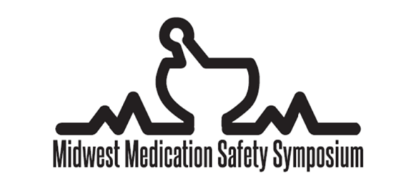
September 19 – 21, 2019

Presentation Proposal Form 2019
Submission Deadline: April 19, 2019
Submit Completed Proposals to: slamscollaborative@gmail.com

GENERAL INFORMATION
Presenting at the annual Midwest Medication Safety Symposium provides an opportunity to build your professional network. Presenting a content-rich session, individually or as part of a team, is a wonderful way to share knowledge, experiences, and ideas. The conference’s program will showcase future directions, best practices, stories of successful collaborations, and lessons learned.

Proposals are selected to ensure the conference offers a comprehensive, nonpromotional, objective, and diverse program. We are looking for proposals that cover a variety of medication safety related topics pertinent to all disciplines. Topics suggested by prior meeting attendees have included: safe management of medication in renally impaired, drug interaction safety, expanded pharmacy technician roles, vaccine safety, transitions of care, pump integration, ambulatory medication safety, and medication administration safety.

PRESENTER INFORMATION
First Name: |  | Middle Initial: | Last Name:
Credentials: |  | Role: | Institution:
Email: |  | Phone:
[STUDENTS ONLY] Please indicate which preceptor will assist you with the preparation of your presentation:

Will you have co-presenter(s)?  ☐Yes ☐No |  | If so, please list name(s) and disciplines of co-presenters:
Would you like the Programming Committee to identify co-presenter(s) for you? (co-presenters not required)
☐Yes ☐No
PRESENTATION INFORMATION
Title:
Desired Type and Length of Presentation (please check any that would be an option):
☐ Platform Presentation – 30 minutes (minimal active learning; CE questions acceptable)
☐ Platform Presentation – 45 minutes (required active learning beyond CE questions)
☐ Platform Presentation – 60 minutes (no more than 30 minutes of didactic lecture; 30+ minutes small group work)
☐ Clinical Pearl – 8 minutes (opportunity to share a short, novel safety story or project containing free standing, clinically relevant information based on experience or observation)
☐ Poster Presentation (final results are not required at time of presenting)

If not selected for a Platform Presentation, would you be willing to present your idea as a Clinical Pearl or Poster Presentation instead?
☐ Yes; ☐ No; ☐ N/A (I submitted for a Clinical Pearl and/or Poster Presentation only)
Learning Objectives (for Platform Presentations only):
1.

2.

3.

Brief description (2-3 sentences describing overall goal of the presentation/pearl/poster and major topics to be covered):
Interactive Learning Strategies (required for Platform Presentation proposals, check all that apply):
☐Audience poll  ☐Game  ☐Small group activity | ☐Patient cases  ☐Practical examples  ☐Learning Assessment Questions |  |  | ☐Think, pair, share  ☐Think, write, share  ☐Other (please specify):
If accepted, you will be asked to submit additional paperwork for CE purposes.
Slides, presentation materials, and CE paperwork will be due at the end of June.

